**THE PERFORMER RELEASE / WAIVER MUST BE COMPLETED AND TURNED IN AT THE TIME OF YOUR AUDITION OR EMAILED TO** [**ARTSCOUNCILMENIFEE@GMAIL.COM**](mailto:ARTSCOUNCILMENIFEE@GMAIL.COM) **IF YOUR AUDITION IS ONLINE.**



PERFORMER RELEASE / WAIVER

**1. Name of Individual, Band or Group (herein called Performer):** ____________________________________________________________(Please Print)

**Name of individual authorized to contract and negotiate on behalf of Band or Group (herein called Leader):** ____________________________________________________________(Please Print)

** If the Performer(s) is under eighteen (18) years old or otherwise legally unable to contract, the Performer's parent or legal guardian must designate him/herself as Leader.

**2. Title of Event:** Menifee's Got Talent - 2025 (Sponsored by Arts Council Menifee)

**3. Date(s):** Dress Rehearsal: June 5, 2025 (5-8p.m.) - Live Performance: June 6, 2025 (7-9:00p.m.)   
 Performances will also be posted online at https://www.artscouncilmenifee.org

**4. Address or Place of Performance and Recording (herein called Venue):** Liberty High School, 32255 Leon Road, Winchester, CA 92596

Performer/Leader agrees to hold Venue harmless from any economic or injury related liability arising from performance at Venue. To the best of Venue’s knowledge, Venue asserts that facilities and equipment at Venue are in good working order.

Performer/Leader and stage crew use the above specifically listed facility/equipment not in good working order at their own risk. Acts of God and temporary or spontaneous failure of equipment are not the responsibility of Venue.

**5.** Performer/Leader declares that Performer/Leader have the appropriate right(s) to perform the tracks, music arrangements or backing used in our (my) performance and hold Venue and Sponsor harmless from any and all copyright infringement or royalty liability.

This contact shall be governed by the construed in accordance with the laws of the State of California (herein called State). Each of the parties in any suit action or proceeding arising out of or relating to this agreement irrevocably submits to the jurisdiction of the State.

**6.** Performer Release

For valuable consideration, the receipt and sufficiency of which are hereby acknowledged, I hereby agree as follows:

Performer/Leader hereby gives and forever grants to Arts Council Menifee (herein called Sponsor ), its advertising agency, licensees and producers or publishers of its promotional materials and their successors and assigns, the right to use, publish and copyright our (my) picture, portrait, likeness, music, lyrics and video in whole or part, including alterations, modifications, derivations and composites thereof, in advertising and promotion of Sponsor events throughout the world. This right shall include the right to combine our (my) likeness with others and to alter our (my) likeness, by digital means or otherwise, for the purposes set forth herein.

IN WITNESS WHEREOF, the undersigned has executed the foregoing instrument on this ____________ day of _________________________ 2025.

Performer/Leader Signature: _____________________________________________________________

Performer/Leader Name (print): __________________________________________________________

Performer/Leader Email: ________________________________________________________________

Phone: ______________________________

Performer/Leader Address: ______________________________________________________________

**IN THE EVENT PERFORMER(s) IS NOT OF AGE OR CAPACITY TO CONTRACT**

If Performer(s) is under eighteen (18) years old or otherwise legally unable to contract, Performer’s parent or guardian must complete and sign the following:

I, ___________________________________ (herein called Parent/Guardian), hereby warrant that I am the Parent or Guardian of Talent, and have full authority to authorize the above, which I have read and approved. I hereby release and agree to indemnify Sponsor and Venue and their respective successors and assigns, from and against any and all liability arising out of the exercise of the rights granted by the above Talent Release.

Parent/Guardian Signature: ___________________________________________ Date: ______________

Parent/Guardian Email: ______________________________________________Phone: _____________

Parent/Guardian Address: _______________________________________________________________

Arts Council Menifee (ACM) www.artscouncilmenifee.org   
Bringing the arts to the community of Menifee and local artists to the public.  
 P.O. Box 385, Menifee, CA 92586 Email: artscouncilmenifee@gmail.com Phone: 951-290-2781

**FILL OUT THIS APPLICATION ONLY IF YOU DO NOT REGISTER ONLINE.**

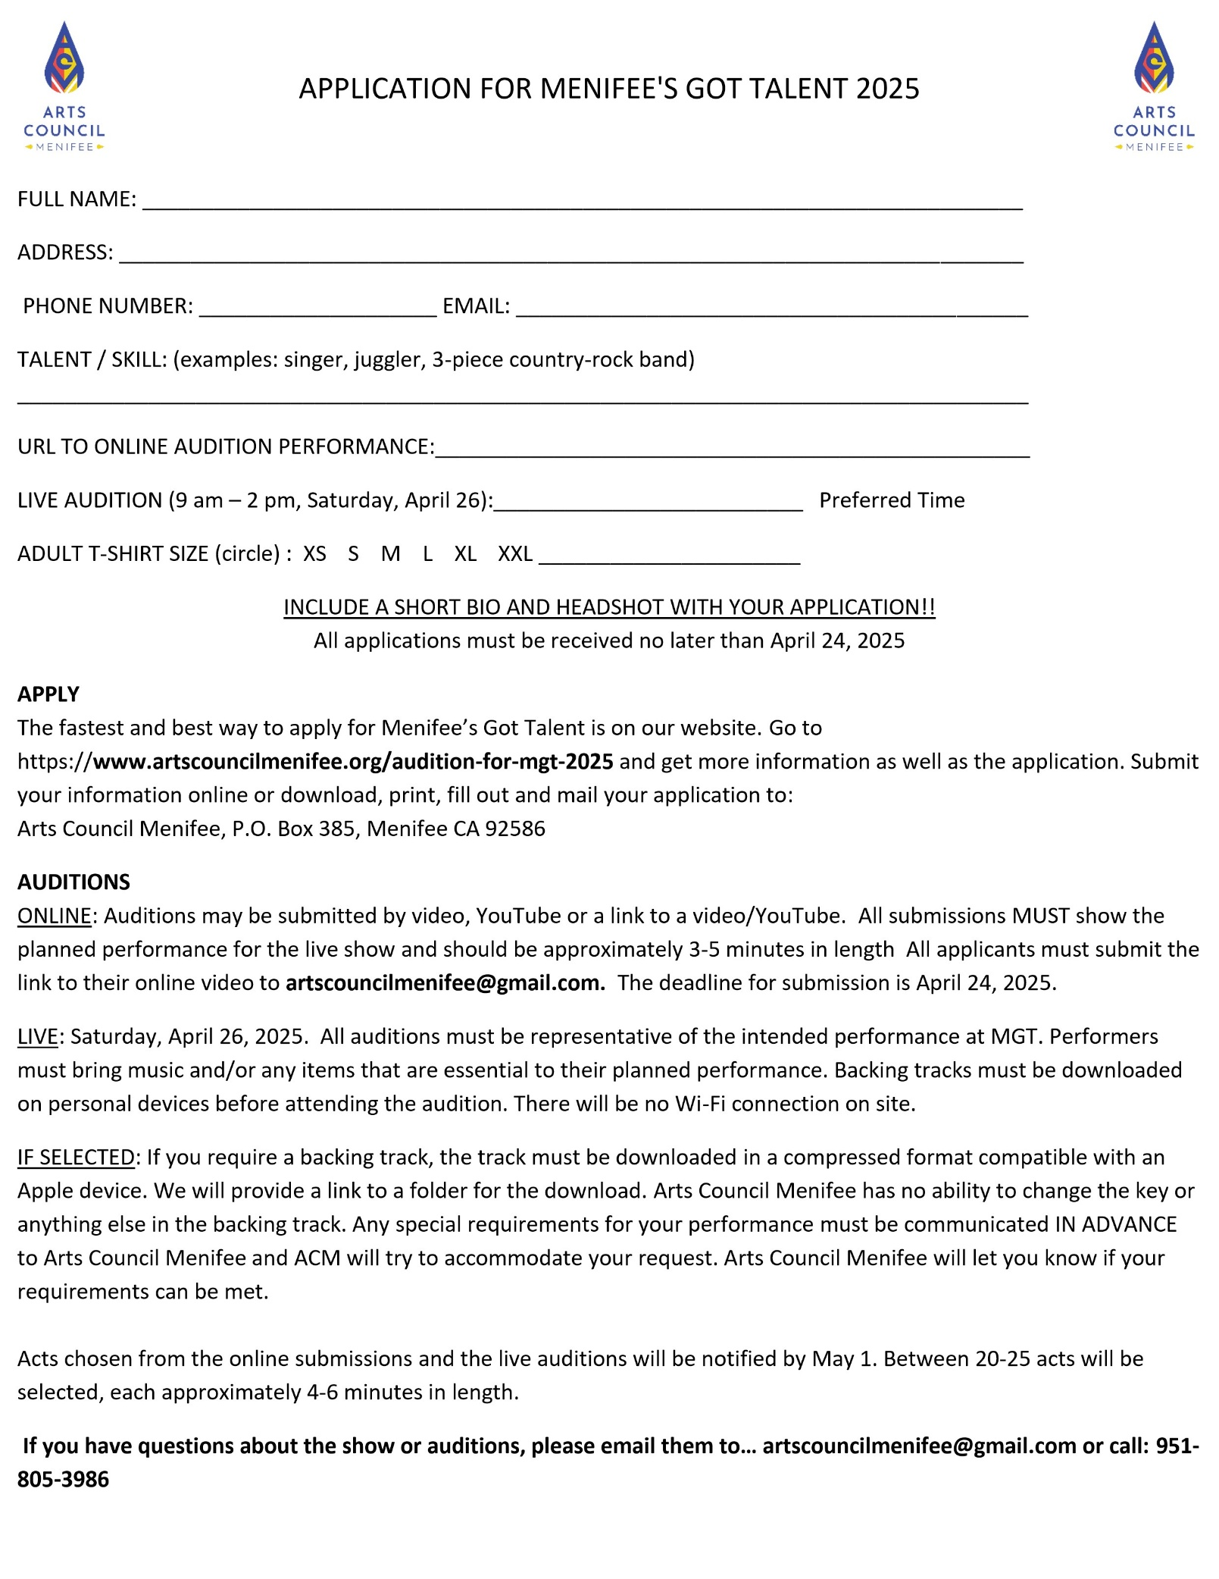

FILL THIS OUT IF YOU ARE INTERESTED IN ADVERTISING IN OUR MGT PROGRAM



